**WEEK-7**

**ReactJS-HOL**

**Exercise 9:**

**App.js**

import React from 'react';

import ListofPlayers from './ListofPlayers';

import IndianPlayers from './IndianPlayers';

function App() {

  const flag = false; // change to false to see other component

  return (

    <div className="App">

      <h1>Cricket App</h1>

      {flag ? <ListofPlayers /> : <IndianPlayers />}

    </div>

  );

}

export default App;

**ListofPlayers.js**

import React from 'react';

const ListofPlayers = () => {

  const players = [

    { name: "Rohit", score: 85 },

    { name: "Virat", score: 95 },

    { name: "Gill", score: 55 },

    { name: "Rahul", score: 65 },

    { name: "Iyer", score: 75 },

    { name: "Pant", score: 45 },

    { name: "Hardik", score: 88 },

    { name: "Jadeja", score: 92 },

    { name: "Bumrah", score: 30 },

    { name: "Shami", score: 55 },

    { name: "Siraj", score: 48 },

  ];

  const allPlayers = players.map((player, index) => (

    <li key={index}>{player.name} - {player.score}</li>

  ));

  const lowScorers = players.filter(player => player.score < 70);

  const lowScoreList = lowScorers.map((player, index) => (

    <li key={index}>{player.name} - {player.score}</li>

  ));

  return (

    <div>

      <h2>All Players</h2>

      <ul>{allPlayers}</ul>

      <h2>Players with score below 70</h2>

      <ul>{lowScoreList}</ul>

    </div>

  );

};

export default ListofPlayers;

**IndianPlayers.js**

import React from 'react';

const IndianPlayers = () => {

  const players = ["Rohit", "Virat", "Gill", "Rahul", "Iyer", "Pant"];

  const [p1, p2, p3, p4, p5, p6] = players;

  const oddPlayers = [p1, p3, p5];

  const evenPlayers = [p2, p4, p6];

  const T20players = ["Rohit", "Virat", "Hardik"];

  const RanjiPlayers = ["Shaw", "Pujara", "Saha"];

  const allPlayers = [...T20players, ...RanjiPlayers];

  return (

    <div>

      <h2>Odd Team Players</h2>

      <ul>{oddPlayers.map((p, i) => <li key={i}>{p}</li>)}</ul>

      <h2>Even Team Players</h2>

      <ul>{evenPlayers.map((p, i) => <li key={i}>{p}</li>)}</ul>\

      <h2>Merged T20 + Ranji Players</h2>

      <ul>{allPlayers.map((p, i) => <li key={i}>{p}</li>)}</ul>

    </div>

  );

};

export default IndianPlayers;

**Output: (flag=true)**

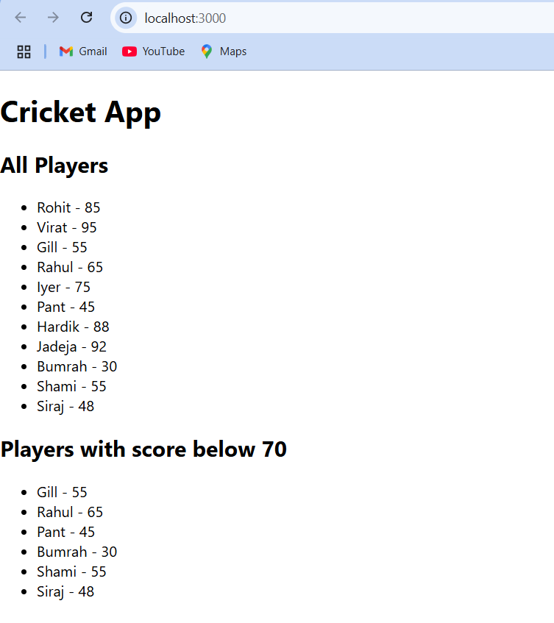

**Output: (flag=false)**

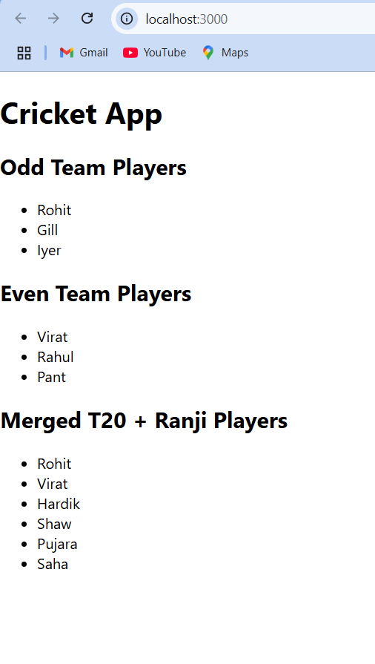

**Exercise 10:**

**->App.js**

import React, { Component } from 'react';

function App() {

  const officeList = [

    { name: "Tech Park", rent: 45000, address: "MG Road, Bangalore" },

    { name: "Startup Hub", rent: 75000, address: "Hitech City, Hyderabad" },

    { name: "Green Workspace", rent: 55000, address: "Baner, Pune" },

    { name: "Sky Tower", rent: 90000, address: "Andheri, Mumbai" },

  ];

  const getRentStyle = (rent) => ({

    color: rent < 60000 ? "red" : "green",

    fontWeight: "bold",

  });

  return (

    <div style={{ textAlign: "center", fontFamily: "Arial" }}>

      {/* Heading */}

      <h1>Office Space Rental</h1>

      {/* Image */}

      <img

        src="https://images.unsplash.com/photo-1504384308090-c894fdcc538d"

        alt="Office Space"

        style={{ width: "400px", borderRadius: "10px" }}

      />

      {/* Office list */}

      <h2>Available Office Spaces</h2>

      <ul style={{ listStyle: "none", padding: 0 }}>

        {officeList.map((office, index) => (

          <li

            key={index}

            style={{

              border: "1px solid #ccc",

              margin: "10px auto",

              width: "400px",

              padding: "10px",

              borderRadius: "8px",

            }}

          >

            <p><strong>Name:</strong> {office.name}</p>

            <p style={getRentStyle(office.rent)}>

              Rent: ₹{office.rent.toLocaleString()}

            </p>

            <p><strong>Address:</strong> {office.address}</p>

          </li>

        ))}

      </ul>

    </div>

  );

}

export default App;

**Output:**

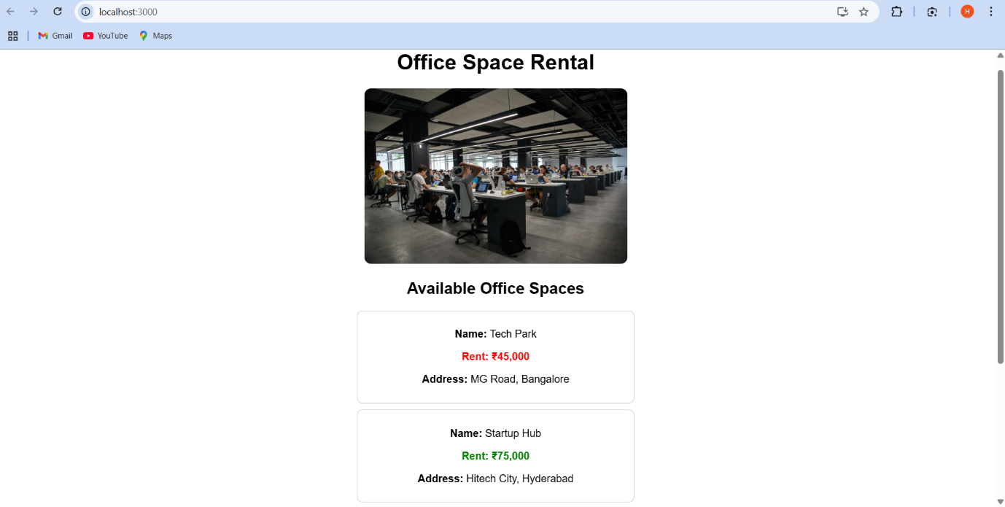

**Exercise 11:**

**->App.js**

import React, { useState } from "react";

import CurrencyConvertor from "./CurrencyConvertor";

function App() {

  const [count, setCount] = useState(0);

  const increment = () => {

    setCount(count + 1);

    sayHello();

  };

  const decrement = () => setCount(count - 1);

  const sayHello = () => {

    alert("Hello! This is an increment action.");

  };

  const sayWelcome = (msg) => {

    alert(msg);

  };

  const handleSyntheticEvent = (event) => {

    alert("I was clicked");

    console.log("Synthetic Event:", event);

  };

  return (

    <div style={{ textAlign: "center", marginTop: "30px" }}>

      <h1>Event Handling Example</h1>

      {/* Counter Section */}

      <h2>Counter: {count}</h2>

      <button onClick={increment}>Increment</button>

      <button onClick={decrement} style={{ marginLeft: "10px" }}>

        Decrement

      </button>

      <br /><br />

      {/* Button with argument */}

      <button onClick={() => sayWelcome("Welcome to React Events!")}>

        Say Welcome

      </button

      <br /><br /

      {/* Synthetic Event */}     <button onClick={handleSyntheticEvent}>OnPress</button

      <br /><br />

      {/* Currency Converter Component */}

      <CurrencyConvertor />

    </div>

  );

}

export default App;

**->CurrencyConvertor.js**

import React, { useState } from "react";

function CurrencyConvertor() {

  const [rupees, setRupees] = useState("");

  const [euro, setEuro] = useState(null);

  const handleSubmit = (e) => {

    e.preventDefault();

    const converted = (parseFloat(rupees) / 90).toFixed(2); // Approx 1 Euro = 90 INR

    setEuro(converted);

  };

  return (

    <div style={{ marginTop: "30px" }}>

      <h2>Currency Converter (INR → Euro)</h2>

      <form onSubmit={handleSubmit}>

        <input

          type="number"

          placeholder="Enter amount in INR"

          value={rupees}

          onChange={(e) => setRupees(e.target.value)}

          required

        />

        <button type="submit" style={{ marginLeft: "10px" }}>

          Convert

        </button>

      </form>

      {euro !== null && (

        <p>

          <strong>{rupees} INR = {euro} EUR</strong>

        </p>

      )}

    </div>

  );

}

export default CurrencyConvertor;

**Output:**

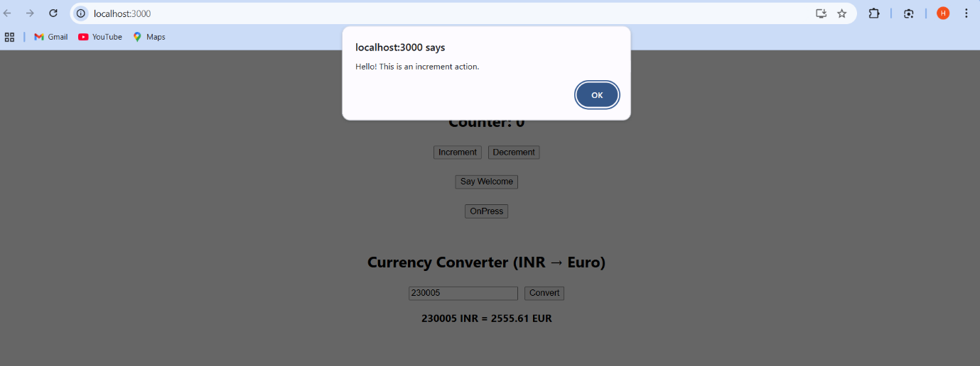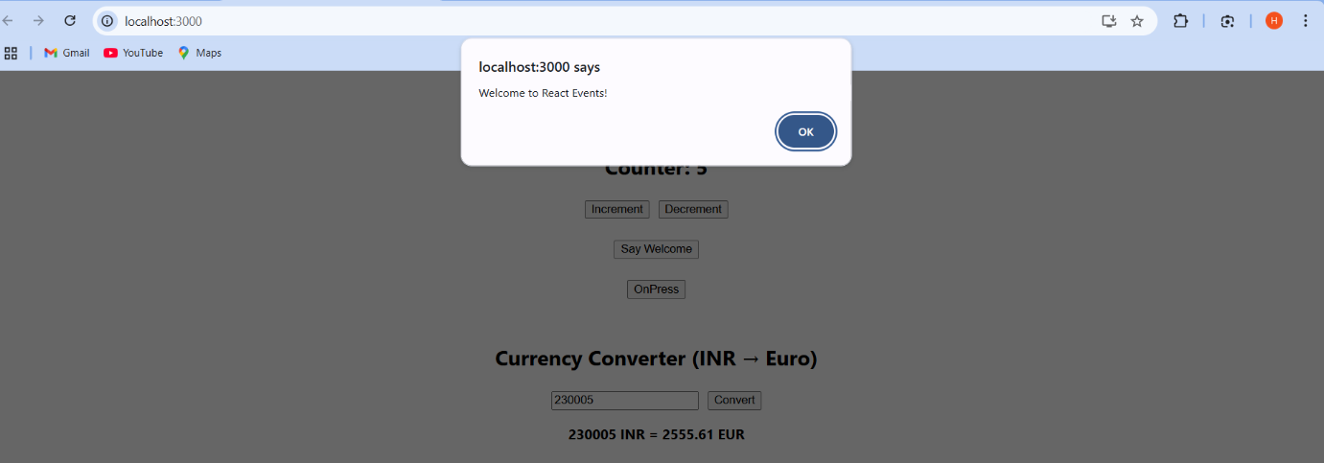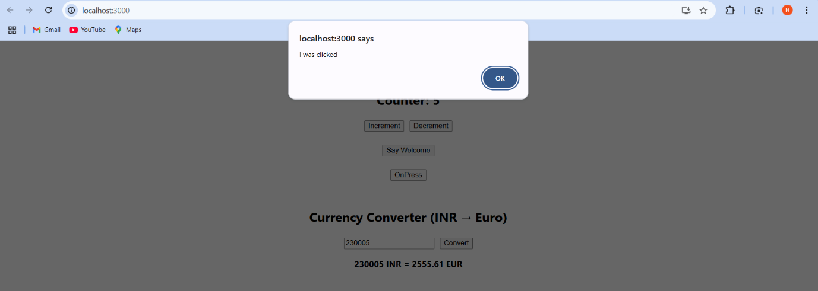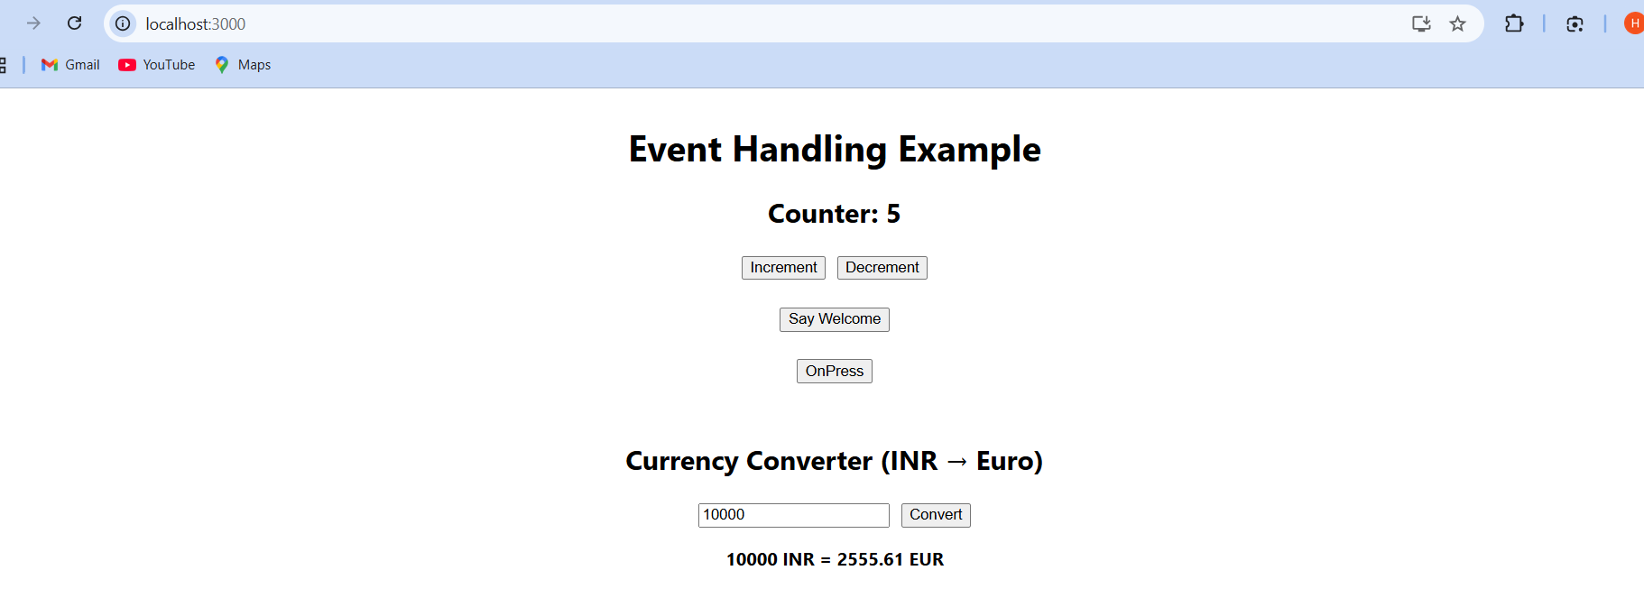

**Exercise 12:**

**GuestPage.js**

import React from 'react';

const GuestPage = () => {

  return (

    <div>

      <h2>Welcome Guest!</h2>

      <p>Please login to book your tickets.</p>

      <p>Flight Details:</p>

      <ul>

        <li>Flight A - 10:00 AM</li>

        <li>Flight B - 1:00 PM</li>

        <li>Flight C - 6:00 PM</li>

      </ul>

    </div>

  );

};

export default GuestPage;

**UserPage.js**

import React, { Component } from "react";

const UserPage = () => {

  return (

    <div>

      <h2>Welcome User!</h2>

      <p>You can now book your tickets.</p>

      <button>Book Now</button>

    </div>

  );

};

export default UserPage;

**LoginControl.js**

import React, { useState } from 'react';

import GuestPage from './GuestPage';

import UserPage from './UserPage';

const LoginControl = () => {

  const [isLoggedIn, setIsLoggedIn] = useState(false);

  const handleLoginClick = () => setIsLoggedIn(true);

  const handleLogoutClick = () => setIsLoggedIn(false);

  let button;

  let page;

  if (isLoggedIn) {

    button = <button onClick={handleLogoutClick}>Logout</button>;

    page = <UserPage />;

  } else {

    button = <button onClick={handleLoginClick}>Login</button>;

    page = <GuestPage />;

  }

  return (

    <div>

      {button}

      {page}

    </div>

  );

};

export default LoginControl;

**App.js**

import React from "react";

import './App.css';

import LoginControl from './components/LoginControl';

function App() {

  return (

    <div className="App">

      <h1>Ticket Booking App</h1>

      <LoginControl />

    </div>

  );

}

export default App;

**Output:**

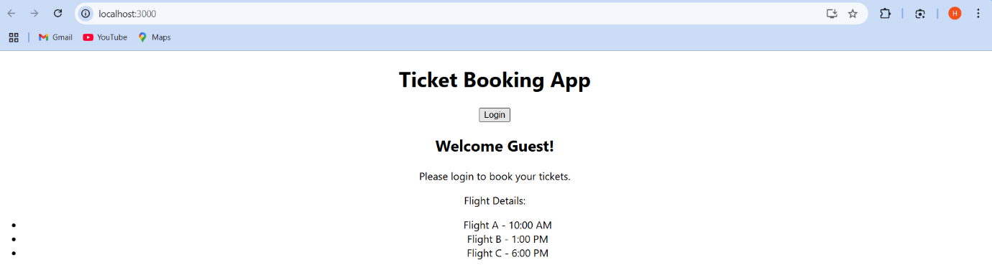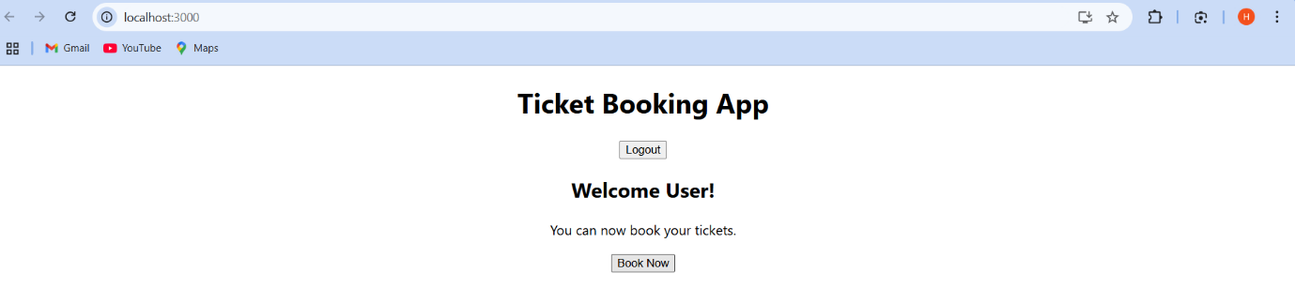

**Exercise:13**

**BookDetails.js**

import React from 'react';

const books = [

  { title: 'Master React', price: 670 },

  { title: 'Deep Dive into Angular 11', price: 800 },

  { title: 'Mongo Essentials', price: 450 }

];

const BookDetails = () => {

  return (

    <div className="section">

      <h2>Book Details</h2>

      {books.map((book, index) => (

        <div key={index}>

          <strong>{book.title}</strong>

          <p>{book.price}</p>

        </div>

      ))}

    </div>

  );

};

export default BookDetails;

**BlogDetails.js**

import React from 'react';

const blogs = [

  {

    title: 'React Learning',

    author: 'Stephen Biz',

    description: 'Welcome to learning React!'

  },

  {

    title: 'Installation',

    author: 'Schwezdzenier',

    description: 'You can install React from npm.'

  }

];

const BlogDetails = () => {

  return (

    <div className="section">

      <h2>Blog Details</h2>

      {blogs.map((blog, index) => (

        <div key={index}>

          <h3>{blog.title}</h3>

          <p><strong>{blog.author}</strong></p>

          <p>{blog.description}</p>

        </div>

      ))}

    </div>

  );

};

export default BlogDetails;

**CourseDetails.js**

import React from 'react';

const CourseDetails = () => {

const courses = [

{ name: 'Angular', date: '4/5/2021' },

{ name: 'React', date: '6/3/20201' }

];

return (

<div className="section">

<h2>Course Details</h2>

{courses.map((course, index) => (

<div key={index}>

<h3>{course.name}</h3>

<p>{course.date}</p>

</div>

))}

</div>

);

};

export default CourseDetails;

**ContentSwitcher.js**

import React, { useState } from 'react';

import BookDetails from './BookDetails';

import BlogDetails from './BlogDetails';

import CourseDetails from './CourseDetails';

const ContentSwitcher = () => {

  const [content, setContent] = useState('book');

  const renderContent = () => {

    switch (content) {

      case 'book':

        return <BookDetails />;

      case 'blog':

        return <BlogDetails />;

      case 'course':

        return <CourseDetails />;

      default:

        return null;

    }

  };

  return (

    <div>

      <h1>Blogger App</h1>

      <button onClick={() => setContent('book')}>Book Details</button>

      <button onClick={() => setContent('blog')}>Blog Details</button>

      <button onClick={() => setContent('course')}>Course Details</button>

      <hr />

      {renderContent()}

    </div>

  );

};

export default ContentSwitcher;

**Output:**

